

BEng(Hons) Software Engineering

Module Name | 4COSC006C- Software Development -I
Module Leader | Mr. Guhanathan Poravi
Assessment Type | Individual
Assessment Number | Stage 03
Student ID | 20231970 – IIT  W2149655 – UoW
Student Name | Mr. K. M. Palansuriya
Issue Date | Tuesday 19th Feb 2025
Submission Date | Monday 21st Apr 2025
Contents
Test Cases for JSON file operations 4
Test Cases and Results 4
Test Case 01 – Loading tasks from JSON 4
Test Case 02 – Adding a new task 5
Test Case 03 – View tasks 7
Test Case 04 – Updating a task 8
Test Case 05 – Deleting a Task 10
Test Case 06 – Adding a task with invalid input of the task name 11
Test Case 07 - Adding a task with invalid priority 12
Test Case 08 - Adding a task with invalid date format 13
Test Case 09 - Adding a task with valid input 14
Test Case 10 – Exit 16

Table 1 - Loading tasks from JSON 4
Table 2 - Adding a new task 5
Table 3 - View tasks 7
Table 4 - Updating a task 8
Table 5 - Deleting a Task 10
Table 6 - Adding a task with invalid input of the task name 11
Table 7 - Adding a task with invalid priority 12
Table 8 - Adding a task with invalid date format 13
Table 9 - Adding a task with valid input 14
Table 10 - Exit 16

Figure 1 - Loading tasks from JSON (JSON FILE) 5
Figure 2- Adding a new task (JSON FILE) 6
Figure 3 - Updating a task (JSON FILE) 9
Figure 4 - Deleting a Task (JSON FILE) 11
Figure 5 - Adding a task with valid input (JSON FILE) 15

Test Case 1 - Adding a new task (IDLE FILE) 6
Test Case 2 - View tasks (IDLE FILE) 7
Test Case 3 - Updating a task (IDLE FILE) 9
Test Case 4 - Deleting a Task (IDLE FILE) 10
Test Case 5 - Adding a task with invalid input of the task name (IDLE FILE) 12
Test Case 6 - Adding a task with invalid priority (IDLE FILE) 13
Test Case 7 -Adding a task with invalid date format (IDLE FILE) 14
Test Case 8 - Adding a task with valid input (IDLE FILE) 15
Test Case 9 - Exit 16

Test Cases for JSON file operations

Test Cases and Results

Test Case 01 – Loading tasks from JSON

Table 1 - Loading tasks from JSON
Test  Case | Input | Expected  Outcomes | Actual  Outcomes | Result
loading tasks from JSON | Start the program | The program loads tasks from the Json file of “tasks.json” file if it exists. If no file exists. It initializes an empty task list | Tasks are loaded from the tasks.json file. If the file does not exist an empty list is initialized in the json file | Pass

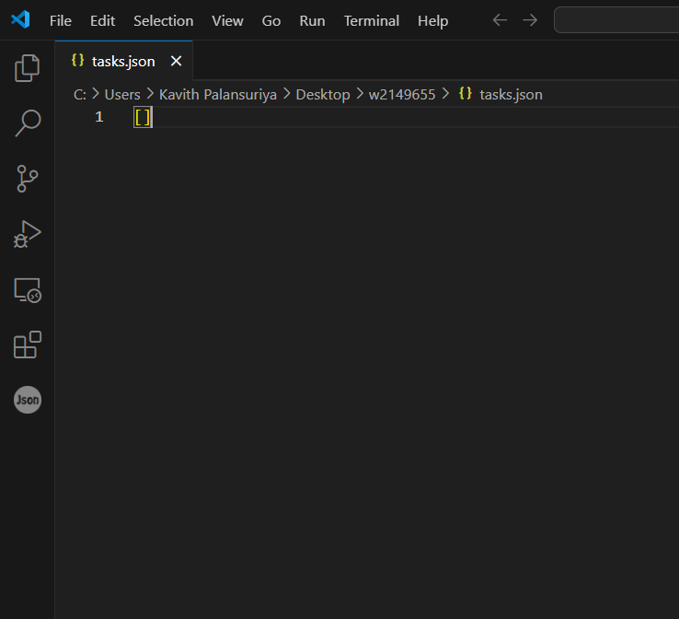
Figure 1 - Loading tasks from JSON (JSON FILE)

Test Case 02 – Adding a new task

Table 2 - Adding a new task
Test  Case | Input | Expected  Outcomes | Actual  Outcomes | Result
Adding a new task | Task Name: “Task 01”, Description:”SD01 Stage 01,02”,  Priority: “medium”  , Due Date:”2025-03-27” | The task is added to the task list and saved to the JSON file. | Task is added to the list and saved to the file | Pass

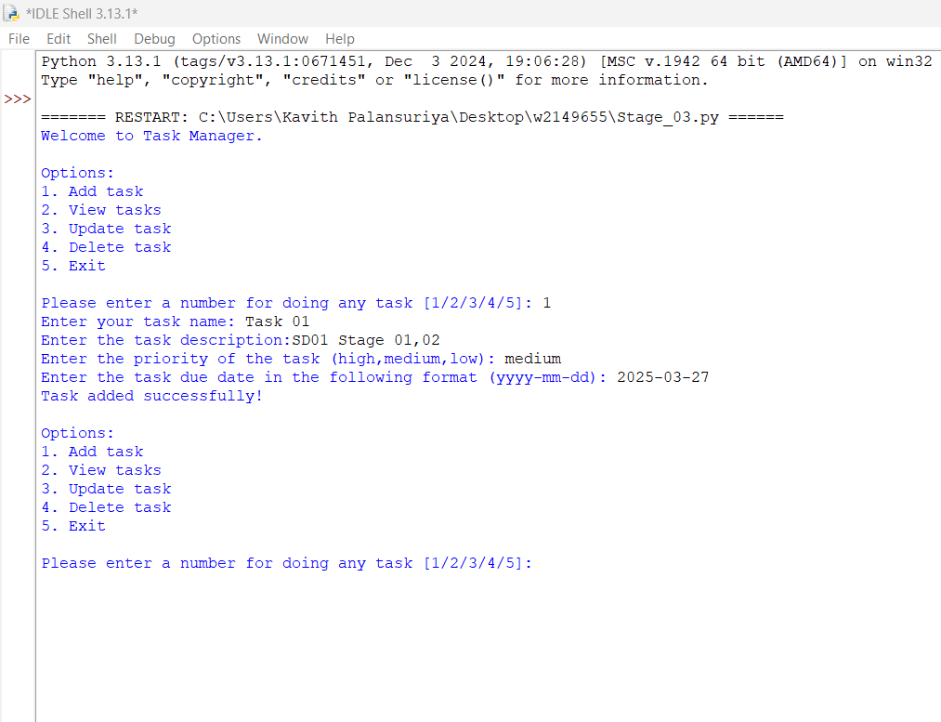
Test Case 1 - Adding a new task (IDLE FILE)

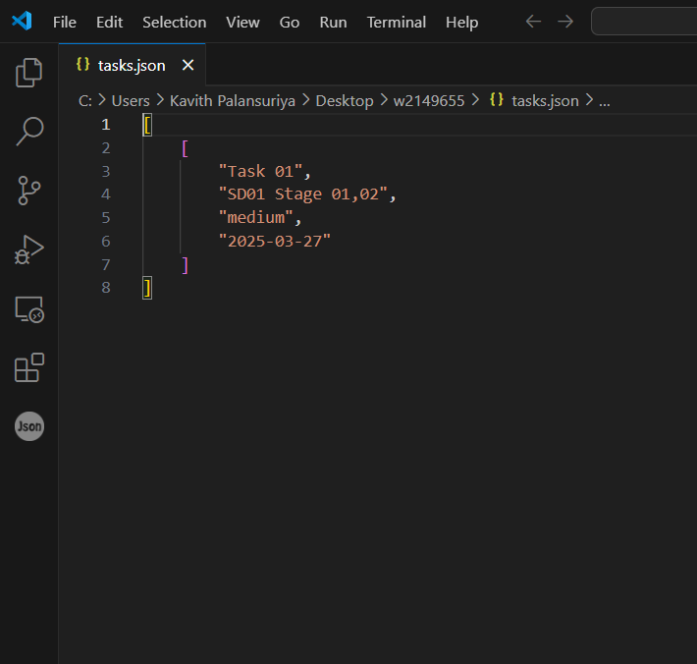
Figure 2- Adding a new task (JSON FILE)

Test Case 03 – View tasks

Table 3 - View tasks
Test  Case | Input | Expected  Outcomes | Actual  Outcomes | Result
View Tasks | After adding a task run the program | The task list is displayed correctly with task details | Tasks are displayed as  Expected in the format (Name, description, priority, due date) | Pass

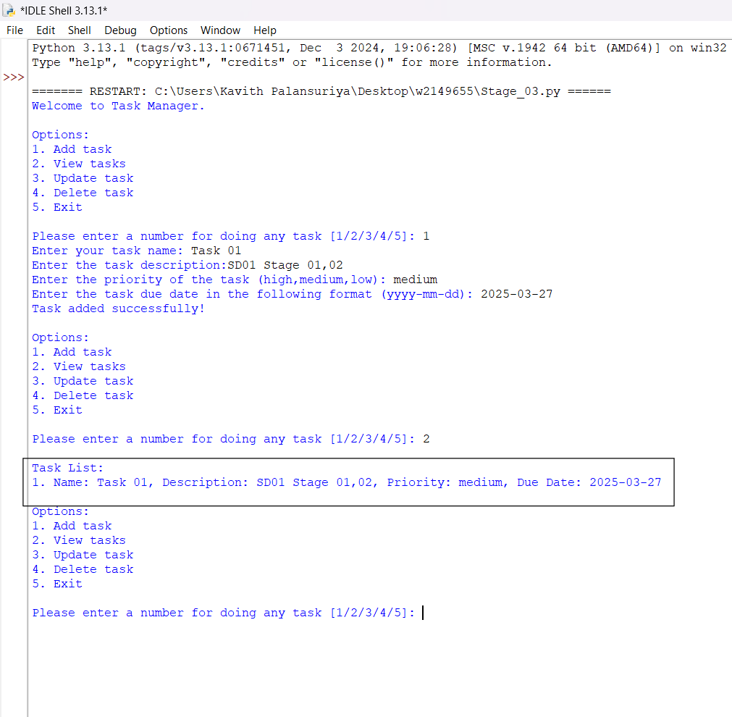
Test Case 2 - View tasks (IDLE FILE)

Test Case 04 – Updating a task

Table 4 - Updating a task
Test  Case | Input | Expected  Outcomes | Actual  Outcomes | Result
Updating a task | Task Name: “Task 01”, Description:”SD01 Stage 01,02”,  Priority: “medium”  , Due Date:”2025-03-27”  Updating this old task into new task  Task Name: “Task 01”, Description:”SD01 Stage 03,04”,  Priority: “high”  , Due Date:”2025-03-27” | The task is updated with the new name, description, and priority. The changes are reflected in the task list and saved to the JSON file | Task is updated with the new  Details, and changes are saved to “tasks.json” | Pass

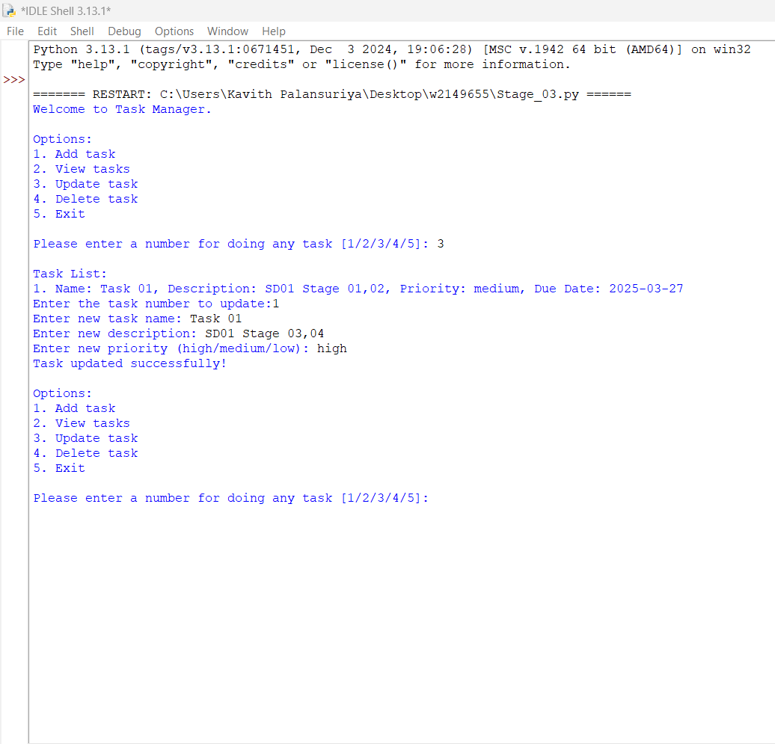
Test Case 3 - Updating a task (IDLE FILE)

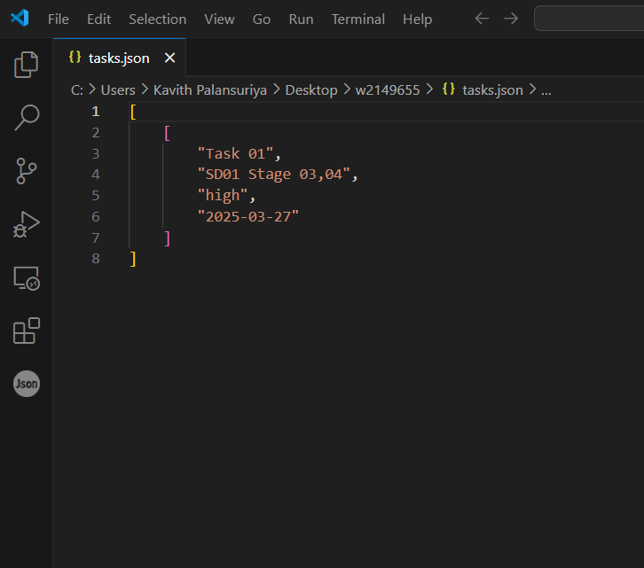
Figure 3 - Updating a task (JSON FILE)

Test Case 05 – Deleting a Task

Table 5 - Deleting a Task
Test  Case | Input | Expected  Outcomes | Actual  Outcomes | Result
Deleting a Task | User to enter option 4 delete task and it shows the list and give Task number 1 to delete | The task is deleted from the task list and the changes are saved to the JSON file | Task is deleted from the list and the changes are saved | Pass

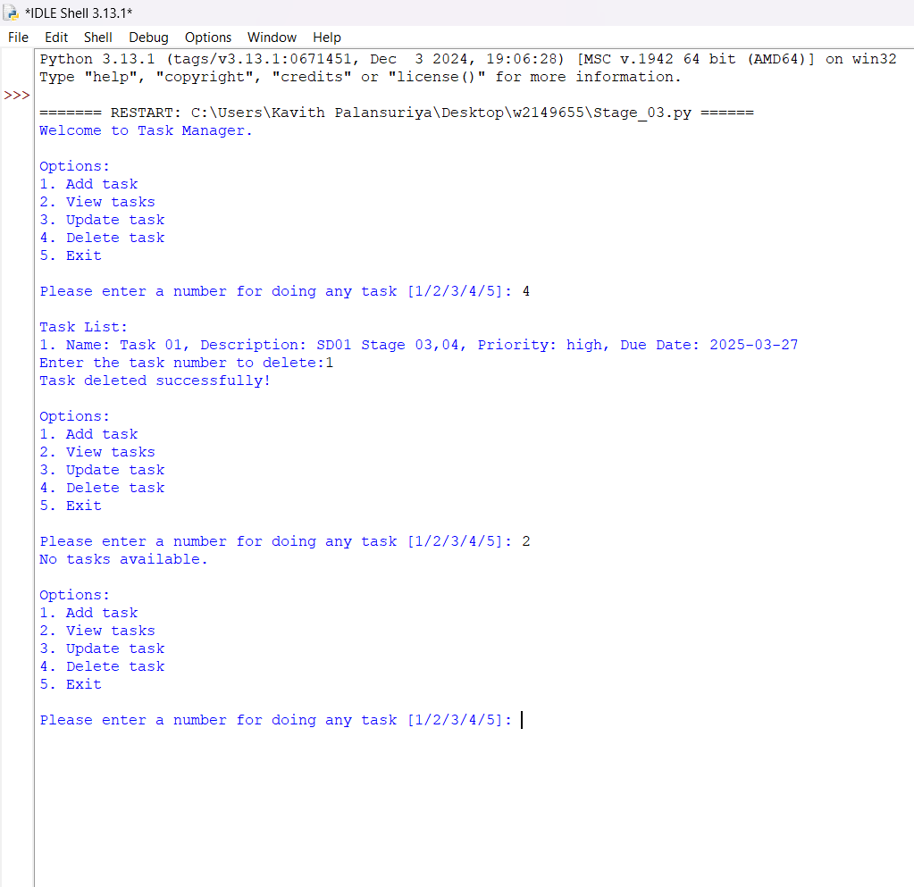
Test Case 4 - Deleting a Task (IDLE FILE)


Figure 4 - Deleting a Task (JSON FILE)

Test Case 06 – Adding a task with invalid input of the task name

Table 6 - Adding a task with invalid input of the task name
Test  Case | Input | Expected  Outcomes | Actual  Outcomes | Result
Adding a task with invalid input of the task name | Task Name: “” | The system requires the user to enter proper task name | User is prompted to enter a proper task name | Pass

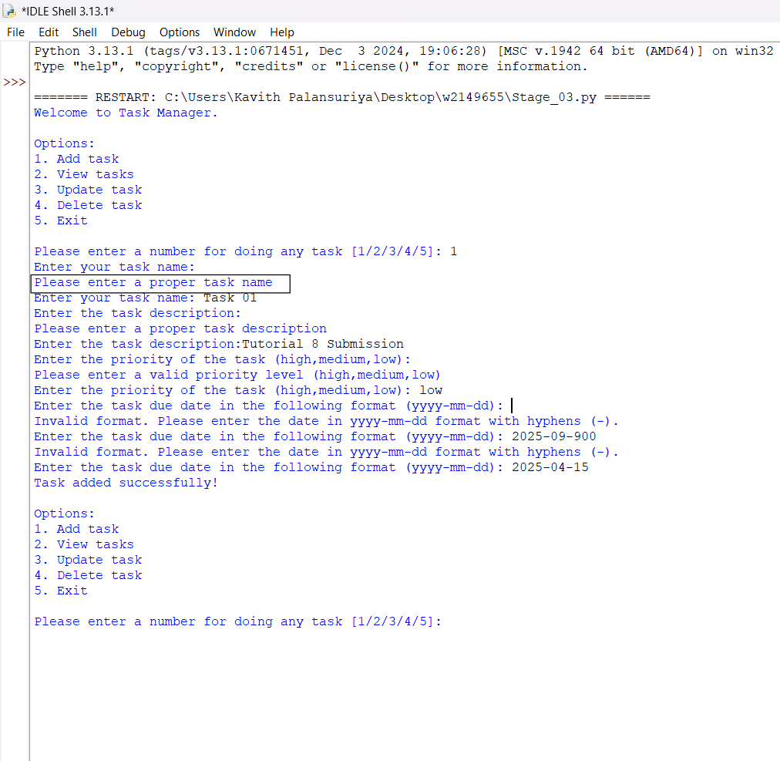
Test Case 5 - Adding a task with invalid input of the task name (IDLE FILE)

Test Case 07 - Adding a task with invalid priority

Table 7 - Adding a task with invalid priority
Test  Case | Input | Expected  Outcomes | Actual  Outcomes | Result
Adding a task with invalid priority | Task Name: “Task 01”, Description: “Tutorial 8 Submission”,  Priority: “” | The system requires from the user to enter a valid priority (“high”,”medium”,”low”) | User is prompted to enter a valid priority | Pass

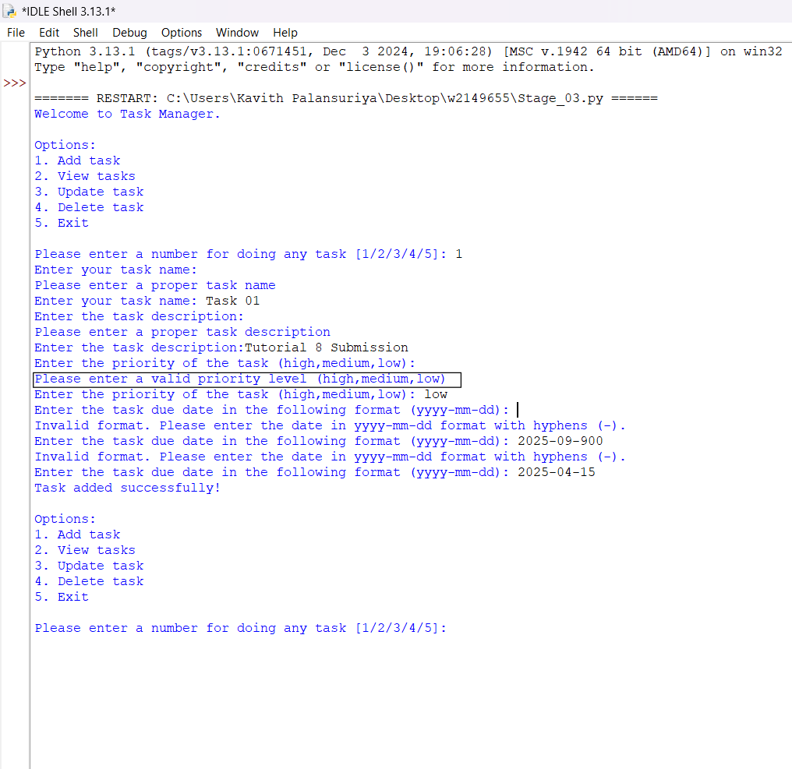
Test Case 6 - Adding a task with invalid priority (IDLE FILE)

Test Case 08 - Adding a task with invalid date format

Table 8 - Adding a task with invalid date format
Test  Case | Input | Expected  Outcomes | Actual  Outcomes | Result
Adding a task with invalid date format | Task Name: “Task 01”, Description: “Tutorial 8 Submission”,  Priority: “low”  , Due Date:”2025-09-900” | The system asks the user to enter a valid due date in this format (yyyy-mm-dd) | User is prompted to enter a valid due date | Pass

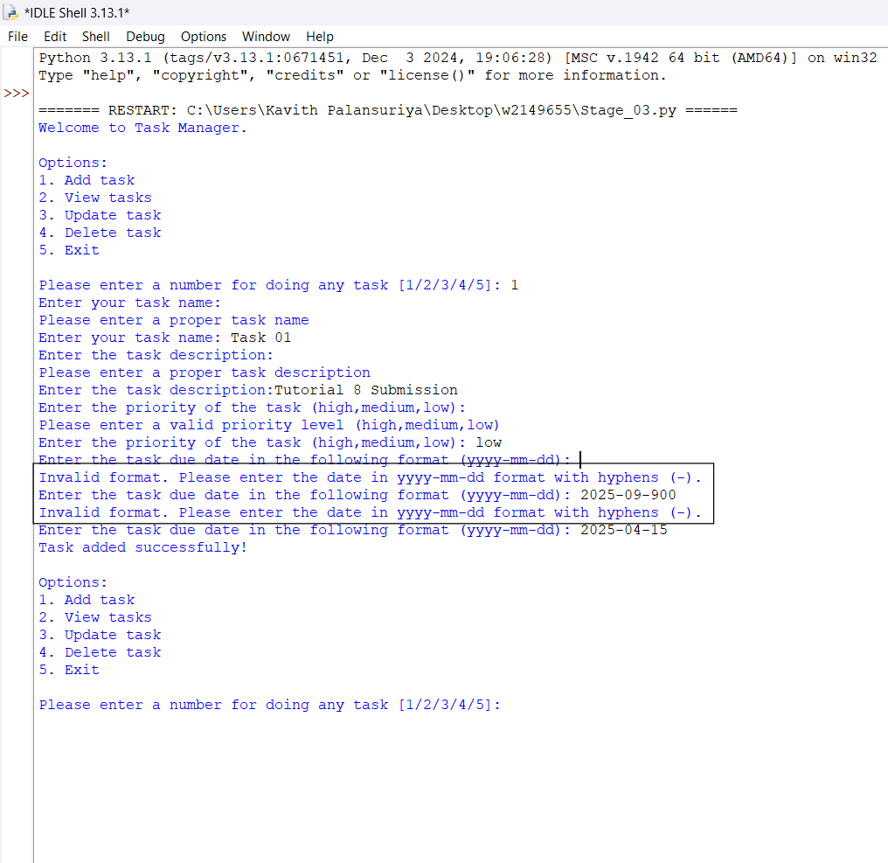
Test Case 7 -Adding a task with invalid date format (IDLE FILE)

Test Case 09 - Adding a task with valid input
Table 9 - Adding a task with valid input
Test  Case | Input | Expected  Outcomes | Actual  Outcomes | Result
Adding a task with valid input | Task Name: “Task 01”, Description: “Tutorial 8 Submission”,  Priority: “low”  , Due Date:”2025-04-15” | Task is added successfully and saved to the JSON file | Task is successfully added and saved | Pass
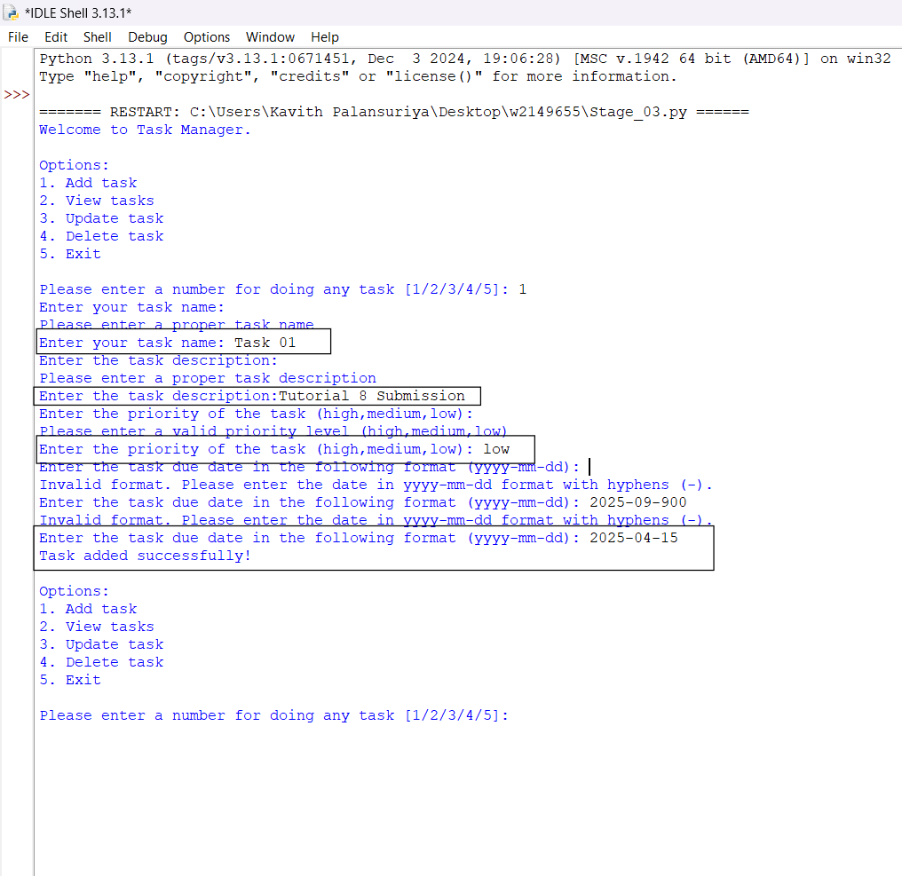
Test Case 8 - Adding a task with valid input (IDLE FILE)

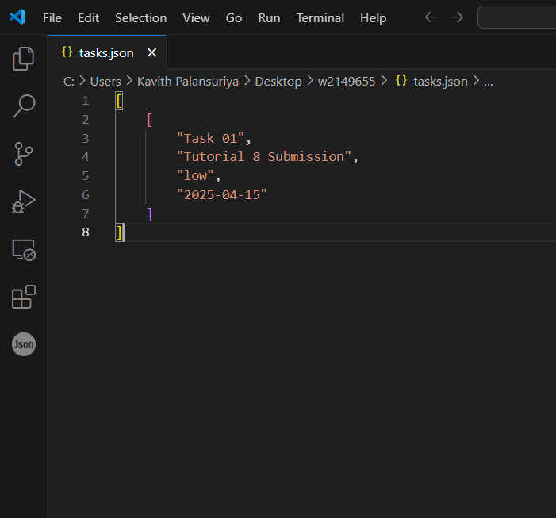
Figure 5 - Adding a task with valid input (JSON FILE)

Test Case 10 – Exit

Table 10 - Exit
Test  Case | Input | Expected  Outcomes | Actual  Outcomes | Result
Exit | User to enter “option 5” | Program should  exit with a massage | Program exited with ‘Thank you for using the system’ | Pass

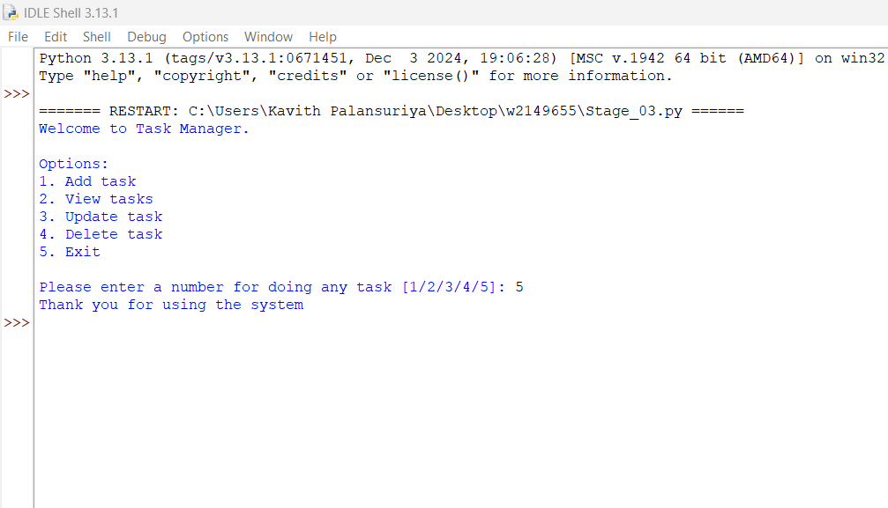
Test Case 9 - Exit

